

CESC.472.601 Authentication and Security Models

Homework 2: Authentication Protocols

*Assigned by: Dr. Wesam Almobaideen*

***Group 5***

Fatima Rabiu

Rania Kanaan

Suhaila Alfalasi

Yara Abdallah

Zaman Hussain

​​Table of Contents

**Abstract 2**

**Introduction: 3**

**Protocol Analysis 4**

Vulnerable Protocol 4

Mutual Authentication Attack 5

Mitigation of the Attack 6

**Implementation of Alice and Bob: 7**

Alice's Role (Client): 7

Bob's Role (Server): 9

Key Points of the Protocol: 11

**Attack against mutual authentication 13**

Attacker ‘Trudy’ Code 13

Implementation of the Attack 15

**Mitigation & Security Analysis: 17**

Alice's Role (Client) - Mitigated Protocol: 17

Bob's Role (Server) - Mitigated Protocol: 19

**Security Analysis 22**

Attack Security Analysis 22

Wireshark analysis 22

TCPdump analysis 27

Mitigation Security Analysis 31

**Conclusion 32**

**References 33**

**Appendix 34**

# 

# 

# 

# 

# 

# 

# 

# Abstract

Authentication protocols are the main factor that guarantees that all the entities in a network will be able to communicate in a secure environment. However, even if the design of the protocol are properly designed, attackers may discover some weaknesses in tha protocols. In this assignment, the core of it is to do the analysis, exploitation, and mitigation of the vulnerable authentication protocol. The main three core goals include the implementation of the original insecure communication protocol, building an attack tool that will be able to eavesdrop and capture the message, then being able to create a protected enhanced version of the protocol to reduce these issues. The implementation of this assignment will require the use of a socket programming to simulate client-server communication. For network monitoring the usage of tools such as Wireshark and tcpdump will be used to analyze the weaknesses in the protocol. Lastly, for the mitigation technique the protocol will be tested against the same attack to determine whether its effective. This assignment will examine every aspect of the original protocol weaknesses along with attack strategies and mitigation solutions of this experimental outcome. The purpose of this implementation is to provide students with the practical knowledge about security flaws identification, attack implementations, and secure authentication protocol development to demonstrate why secure protection of sensitive information matters and the continuation of improvement of the authentication mechanisms.

# 

# Introduction:

A network needs authentication protocols for ensuring safe entity-to-entity communications by establishing identity verification and safeguarding confidential data from unauthorized interception. Security breaches can occur when attackers exploit the vulnerabilities present in well-designed authentication protocols. Students gain practical skills by investigating and protecting a defective authentication protocol through vulnerability identification and attack implementation followed by secure communication technology development. Students must begin through creating a basic protocol which serves as attack surface for replay and man-in-the-middle (MITM) attacks before developing an attack program through utilization of Wireshark and tcpdump tools to intercept communication and perform manipulations. The students will improve the protocol design through the implementation of advanced encryption methods and nonce mechanisms which stop attacks and validate their defense capabilities. This assignment enables students to develop hands-on knowledge about safe protocol development through the study of attachment approaches as they employ network monitoring programs and socket programming to build authentic cybersecurity simulations. The exercise strengthens theoretical knowledge while providing students with skills that help solve actual security problems so they are ready for work in network defense and cybersecurity roles.

# Protocol Analysis

In communication between the client and server, authentication protocols needed to maintain their security while being implemented. These protocols will help in verifying the identities of the two parties as well as help in protecting the message sent between them from third party access. But if the protocol wasn’t designed in a proper design, then there will be security risks in which the communication between the two parties will be vulnerable for attacks.

## Vulnerable Protocol

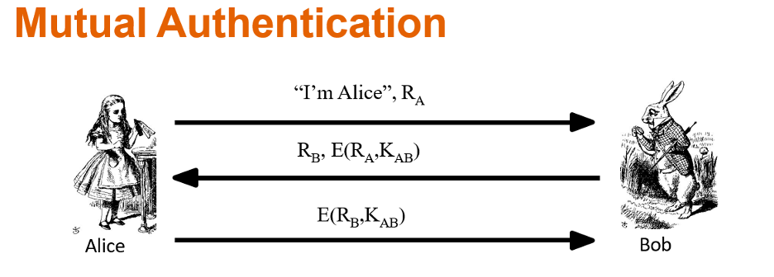

Figure 1. Vulnerable Protocol

An authentication protocol is used in this communication between Alice and Bob that uses a challenge-response method. In the beginning, Alice will send a request to Bob. Bob will respond back with a random value challenge. Once Alice receives the challenge, she will be able to encrypt Bob's challenge using her secret key, then send it back to Bob. Lastly, Bob will check whether the response he received from Alice matches the original challenge he sent in the beginning. But, this method of communication has some security risks which makes this communication vulnerable to an third party interference such as, the attacker can use the challenge, if the challenge is not changing for every attempt, to replay the response to bob into tricking him that will be granting access to the attacker.

## Mutual Authentication Attack

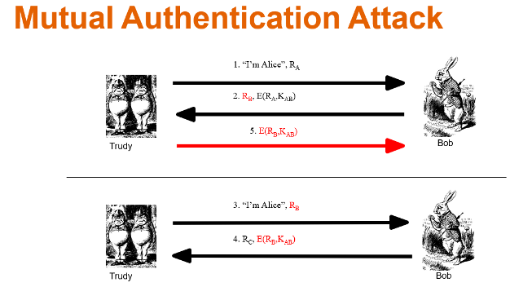

Figure 2. Mutual Authentication Attack

The attack is implemented where a third party called “Trudy” can use the replay attack to capture the previously recorded response that is still active in order to be granted access. Another attack Trudy could implement is the man-in-the-middle where she will be able to interfere and modify the message between Alice and Bob to imitate both parties. As well as, Trudy can listen using monitoring tools such as Wireshark and TCPdump to capture the communication between Alice and Bob when they are exchanging the message between them.

## Mitigation of the Attack

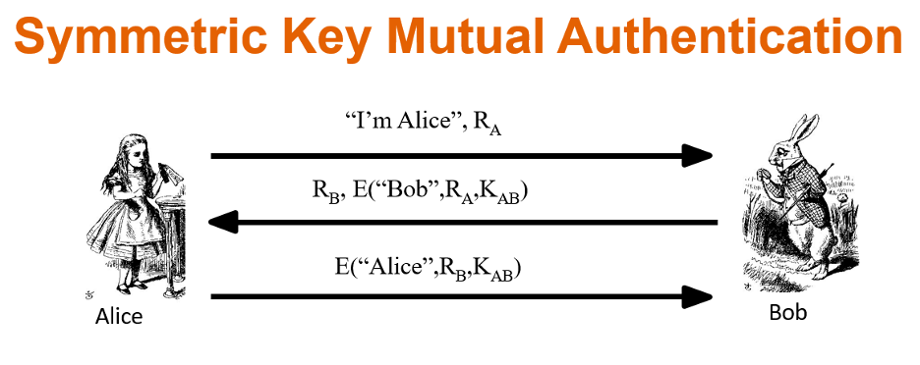

Figure 3. Mitigation Technique

Developing stronger and newer advanced authentication protocols can help in mitigating the security risks from any possible attacks. The communication between Alice and Bob needs to have a more secure encryption method such as, the usage of AES and HMAC encryption techniques in order to protect the message from being altered and intercepted. To prevent attacks such as the replay attack, a nonce is introduced that generates a one time random value that is used per session, so the attacker Trudy was able to obtain the message nonce later on, she won't be able to get access since a newer nonce is generated for every attempt. These mechanisms can help by making things harder for the attacker to intercept between the two communicated parties.

# Implementation of Alice and Bob:

The homework analysis includes Alice as the client and Bob as the server who serve as its main participants. The Homework seeks to build security-authenticated communication between Alice and Bob by monitoring security weak points afterwards and implementing security improvements. The section combines the step-by-step communication between Alice and Bob with coded implementation of their interaction sequences.

## Alice's Role (Client):

Bob initiates authentication processes after Alice sends him requests through his system.

**1- Sending Initial Credentials**:

Alice transmits her username and generated nonce value randomly to Bob through plaintext transmission. Because the communication remains unsecured the possible attack scenarios become visible for any information that passes through this channel.



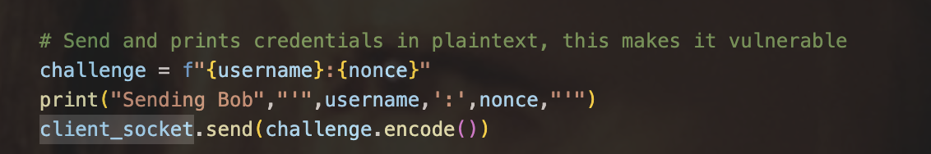Figure 4. Send and prints credentials in plaintext, this makes it vulnerable



Alice constructs an expression from the username alongside nonce (e.g., "Alice:12345") before transmitting it to Bob through the socket channel

**2- Receiving and Decrypting Bob's Response:**

When Alice completes her authentication process she waits for Bob to reply. Bob delivers an encrypted message to Alice with an incorporated challenge consisting of a random nonce. Using a shared encryption key Alice decrypts the received message before checking that the decrypted nonce indeed matches the nonce she previously transmitted. Bob is authenticated whenever his received nonce matches the original nonce sent by Alice.

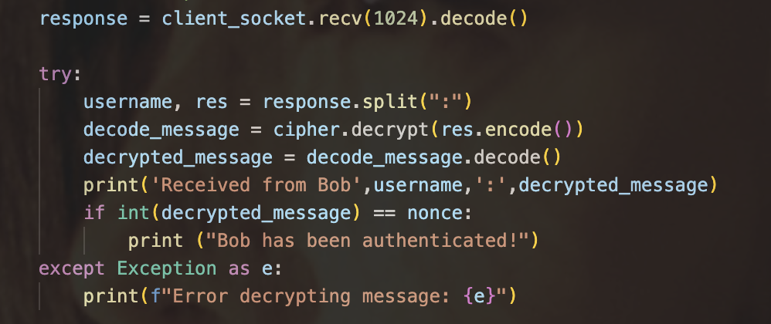

Figure 5. Receive response

**3- Sending Final Response**:

As part of the mutual authentication Bob receives an encrypted version of his nonce from Alice. During this stage Bob secures confident verification of Alice's account.

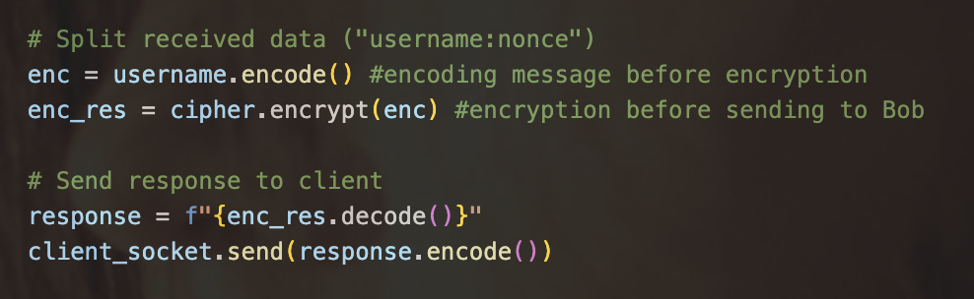

Figure 6. Split Received data

Alice protects Bob's nonce with the shared key before sending it back to him. Alice proves her authenticity to Bob through this step by enabling him to decode the message and validate that the encrypted nonce matches his initial nonce value.

## Bob's Role (Server):

The server role belongs to Bob who must authenticate Alice before fulfilling her service requests.

**1- Receiving Alice's Initial Request:**

When Alice attempts to connect to him Bob actively waits. After Alice transmits her username and nonce to Bob he receives both elements and starts creating a response.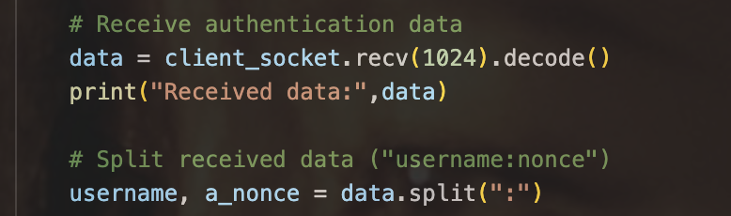

Figure 7. Receive Alice Request

Through the plaintext message Alice sends to Bob he receives both her username and nonce. The message gets separated so he can obtain the username alongside the nonce.

**2- Generating and Encrypting a Challenge:**

Before transmission Bob creates a fresh nonce randomly which he protects using their shared key to reach Alice. Decryption of the protected nonce serves for identity authentication since only Alice can successfully decrypt it.

Figure 8. Generating and Encrypting a Challenge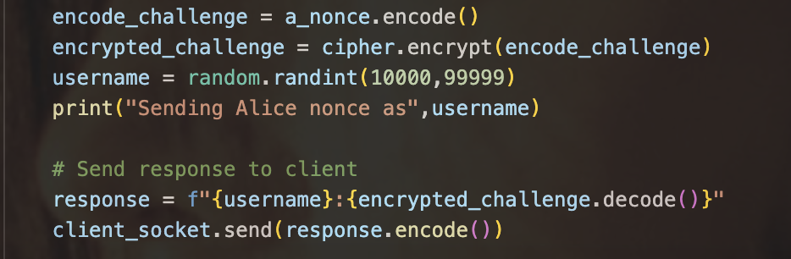

Using the shared encryption key Bob protects Alice's nonce value before delivering this data combined with his newly generated nonce to her. Bob can verify his identity to Alice by letting her decrypt the message.

**3- Verifying Alice's Final Response:**

Bob must wait for Alice to give her final response after executing the challenge process. Alice delivers to Bob the encrypted nonce that Bob achieves by decrypting it and conducting verification procedures. When the decrypted nonce shows a match with the nonce Bob sent initially Alice can be verified as an authentic user.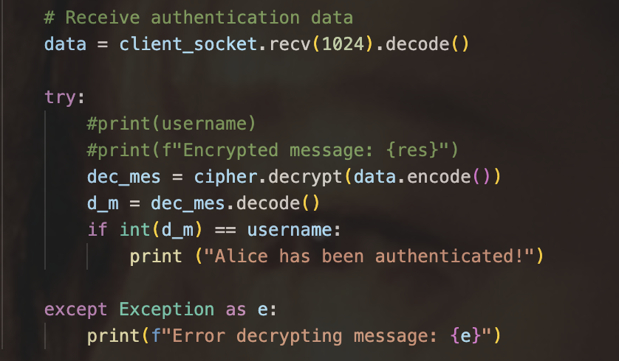

Figure 9. Verifying Alice's Final Response

## Key Points of the Protocol:

**1- Encryption:**

​​Each message requires encryption with Fernet symmetric encryption because Alice and Bob share the encryption key. The encryption provides protection against eavesdropping attacks but the plaintext transfer of username and nonce data makes the system vulnerable before encryption takes effect.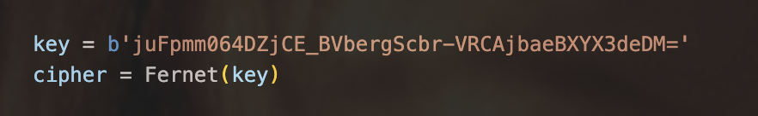

Figure 10. Encryption

The shared key is used to establish the Fernet cipher, which is used for encryption and decryption.

**2- Nonce Usage:**

Each conversation session needs unique random numbers called nonces to protect against manual attacks. During the first execution of the protocol the nonce travels unencrypted therefore putting it at risk for successful interception.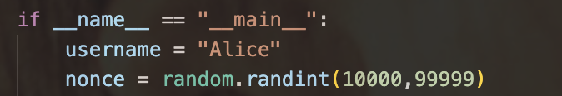

Figure 11. Nonce Usage

Alice and Bob establish random nonces to make sure the communication is fresh

**3- Mutual Authentication:**

Both parties use the system through mutual authentication since they verify each other's identities. The execution of decryption by Alice allows her to authenticate Bob while Bob validates Alice through decryption of her response.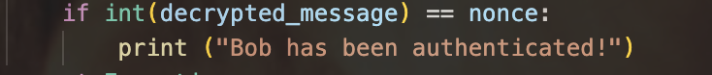

Figure 12. Bob Authentication

Alice analyzes the received nonce after its decryption against the nonce she originally sent.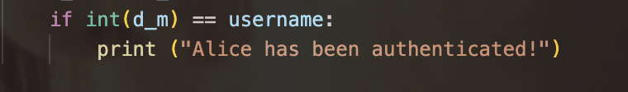

Figure 13. Alice Authentication

Bob verifies Alice through comparison of his original nonce with the decrypted value received from her.

# 

# 

# Attack against mutual authentication

The attack begins when the attacker ‘Trudy’ performs a man-in-the-middle (MITM) attack in order to intercept and try to alter the authentication messages that have been communicated between Alice and Bob. The attacker represents how Trudy will be able to eavesdrop the authentication message communication and captures the encrypted responses and tries to manipulate the response to trick both Alice and Bob in order to gain unauthorised access by modifying their messages.

## Attacker ‘Trudy’ Code

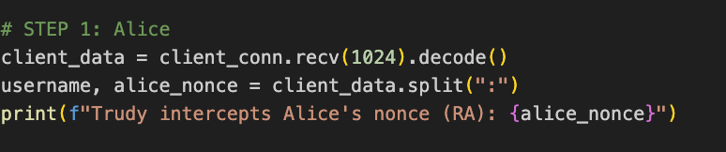

Figure 14. Interception of Alice Message

The attacker ’Trudy’ will eavesdrop on any upcoming message. Alice will send her username along with a nonce (RA) in order to prove her identity. Trudy will be able to intercept that message before reaching Bob and extract the nonce from the message. Gaining the nonce is a critical step for authentication exchange since Trudy can use it later on to trick Bob into being Alice again.



Figure 15. Forwarding Message to Bob

Trudy now can forward the message received from Alice to Bob in order for Bob to think that he is receiving this message from Alice instead of Trudy. Trudy will not alter the message since she wants Bob to respond normally without any suspicion that there is a third party interference to continue the attack successfully.

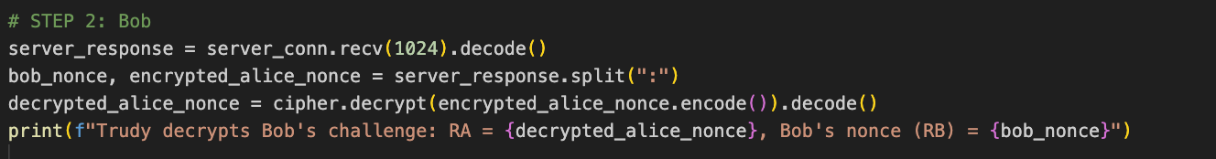

Figure 16. Bob Response

Bob will send the response that contains his nonce (RB) along with an Alice encrypted nonce (RA). Since Trudy was the one that sent Alice nonce (RA), she will be able to decrypt the RA that was encrypted in order to verify that Bob has been tricked and has accepted Alice’s nonce.

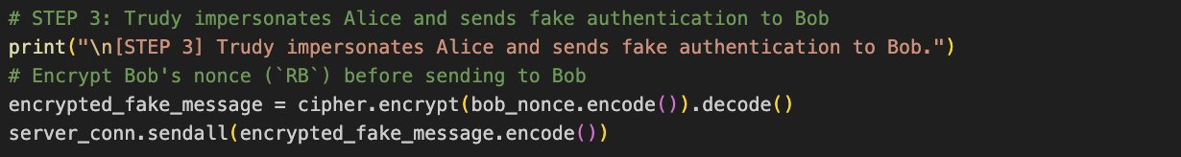

Figure 17. Fake Authentication

Trudy can pretend to be Alice by sending a fake authentication of the encrypted nonce (RB) and sending it back to Bob in order for Bob to think that it came from Alice. Bob will accept the message since the attacker was able to use the correct key for the encryption that shows Bob that Alice's identity has been identified.

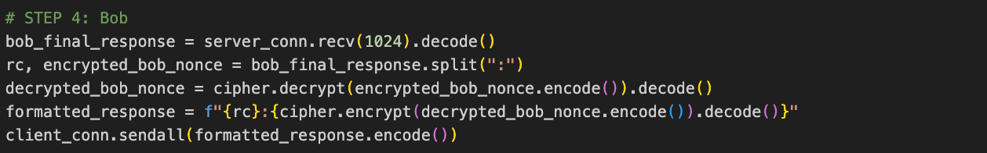Figure 18. Bob Final Response

Lastly, Bob will send a response that contains another nonce (RC) along with his nonce (RB) being encrypted. Trudy will receive that message where she will be able to decrypt RB in order to check its contents then encrypted back to forward it to Alice. Alice will believe that Bob has been replaying her message securely, whereas Alice and Bob don't have a clue that Trudy has been intercepting and modifying the messages.

## Implementation of the Attack

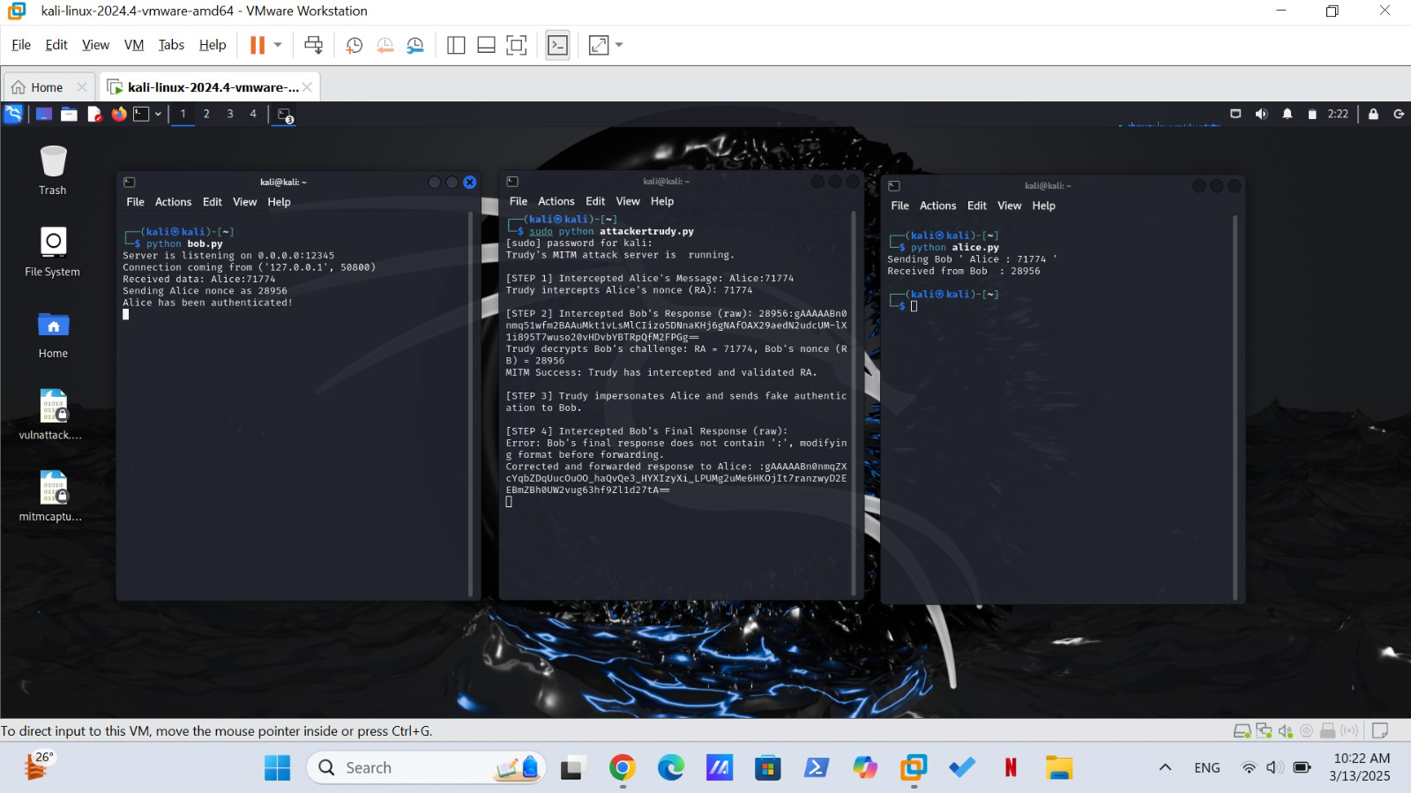

Figure 19. Trudy Interception

In this implementation of the attack, Trudy will be secretly intercepting and manipulating the authentication message communication between Alice and Bob.

* The communication begins when Alice sends a request message of her identity and nonce to Bob that it is present in the terminal running alice.py where Alice sends her ID of (Alice:71774).
* By running the attackertrudy.py, Trudy will be able to capture the authentication message that was meant to be sent to Bob that contains Alice nonce that Trudy will keep record of.
* By using the Alice credentials, Bob will be sending a response with a challenge of his nonce encrypted with her credential. Trudy will intercept Bob's response and decrypt his challenge.
* While Trudy is pretending to be Alice, she will use the messages stored to modify the information and send it to Bob. Without knowing, Bob will authenticate Trudy believing it was Alice.
* In the final response, Bob will respond with an encrypted message which Trudy will successfully capture and modify before forwarding it back. Bob will receive that Alice has been authenticated which in reality it was Trudy who gained the unauthorised access.

# 

# 

# Mitigation & Security Analysis:

The security enhancement process aims to resolve familiar weaknesses in the original protocol by fixing the problem of basic credential transmission and the attacks on session replay. This section presents the mitigation steps followed by the code blocks from your files to demonstrate their implementation.

## Alice's Role (Client) - Mitigated Protocol:

**1- Sending Initial Credentials:**

Alice transmits to Bob both her username along with the nonce she generated securely. The generation of nonce takes place by utilizing os.urandom so the result becomes cryptographic secure.

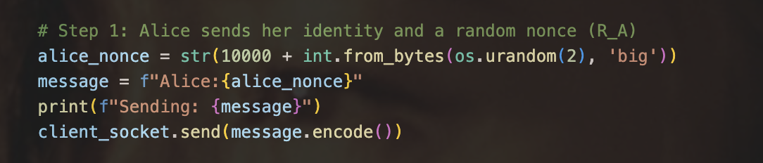Figure 20. Alice sends her identity and a random nonce

Alice conveys her nonce which is secured to Bob next to her login credentials.​​

**2- Receiving and Decrypting Bob's Challenge:**

Bob sends Alice his nonce and encrypted challenge message back to her. Using the shared key she decrypts the challenge before performing identity validation on Bob.

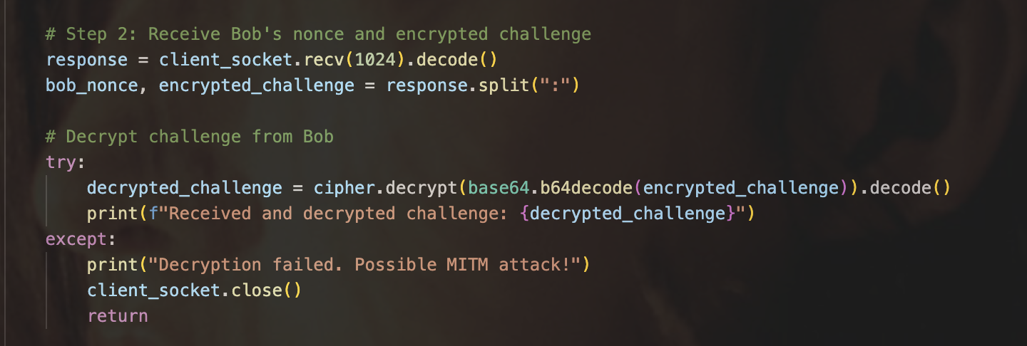Figure 21. Receive Bob's nonce and encrypted challenge

The challenge passes through decryption to Alice who ensures it contains both her original nonce together with Bob's identity. The decryption process fails when a possible man-in-the-middle (MITM) attack occurs.

**3- Sending Final Authentication:**

When Bob passes the identity check Alice proceeds to encrypt the received nonce before sending the authenticated response to Bob.

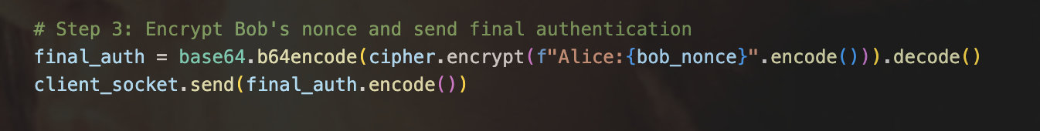

Figure 22. Encrypt Bob's nonce and send final authentication

Alice applies encryption to Bob's nonce which she returns to him for verification purposes.

**4- Receiving Bob's Verification:**

After Bob finishes the verification stage Alice will obtain his final confirmation message for successful authentication.

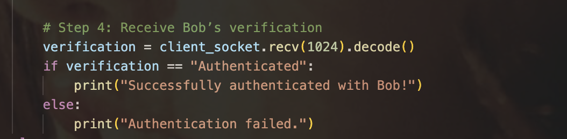Figure 23. Receive Bob's verification

Alice tests if Bob established a proper authentication of her identity.

## Bob's Role (Server) - Mitigated Protocol:

**1- Receiving Alice's Initial Request:**

The message Alice sends to Bob first contains her username as well as her nonce value.

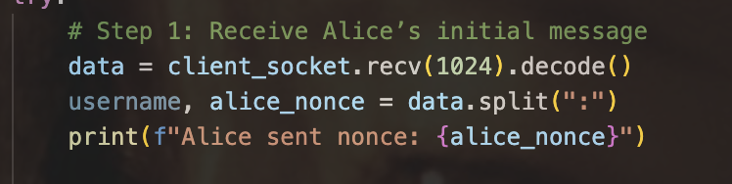

Figure 24. Receive Alice's initial message

When receiving the message Bob extracts both username and nonce that Alice provided.

**2- Generating and Encrypting a Challenge:**

Bob produces his own nonce to make an encrypted challenge including Alice's nonce together with his identification details.

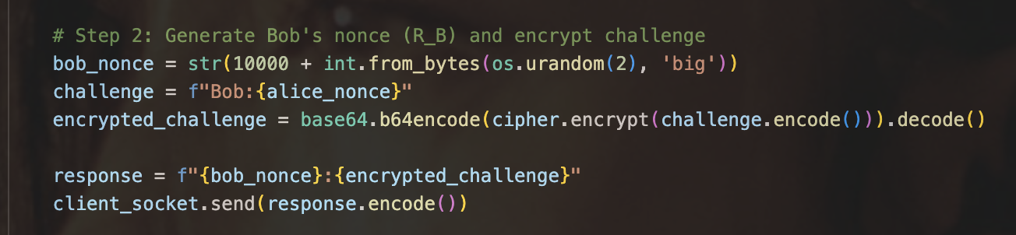

Figure 25. Generate Bob's nonce (RB) and encrypt challenge

The challenge communication receives encryption treatment from Bob before he returns it to Alice along with his nonce value

**3- Receiving and Verifying Alice's Final Authentication:**

Bob reads Alice's ending authentication information, then decrypts it before confirming his nonce is included within that message.

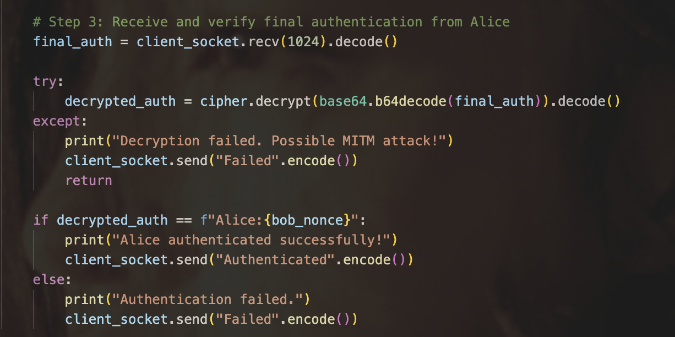

Figure 26. Receive and verify final authentication from Alice

The verification occurs when Bob examines Alice's final message against his initially chosen nonce for matching contents. Authentication of Alice occurs when the servers match the nonce.

**Successful Authentication of Alice and Bob:**

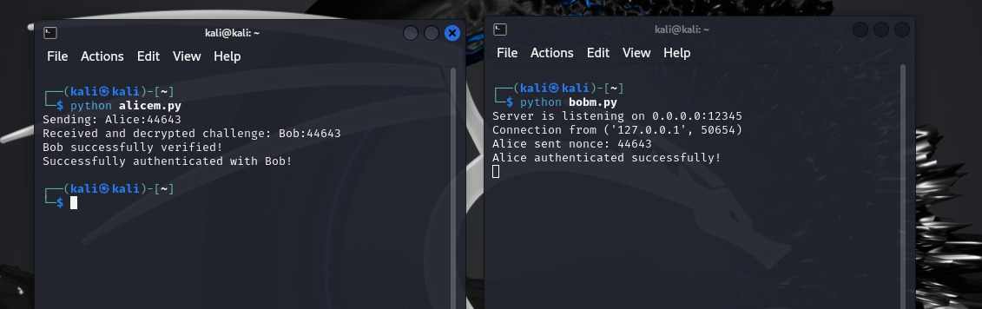

Figure 27. Successful Authentication

Successful authentication between Alice and Bob. After sending her nonce to Bob Alice successfully decrypts his challenge to authenticate before him.

**Failed Authentication Attack Scenario:**

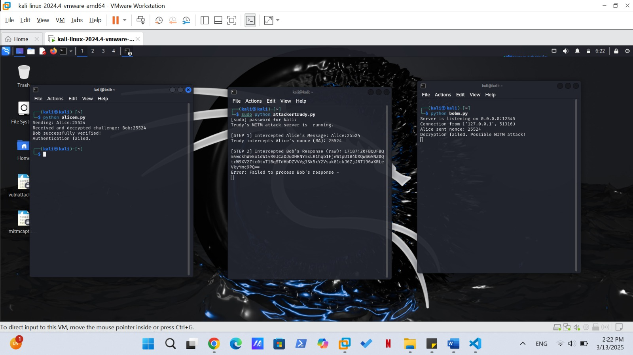

Figure 28. Failed Authentication

Failed authentication scenario due to a possible man-in-the-middle (MITM) attack. When processing the message the decryption fails which results in the interruption of Bob's response showing the requirement for secure protocols.

# Security Analysis

The network security tools Wireshark together with Tcpdump help cyber analysts to analyze and monitor network traffic. The Wireshark tool enables users to view packets through its graphical user interface for real-time observation purposes during technical problem resolution [1]. However, Tcpdump is used as a command-line utility to give the users a simple and more efficient way for checking network packets faster when needing to diagnose in a fast manner with minimal resources [2]. Those two tools function in the same way that help in detecting any upcoming threats where the network communication remains protected.

## Attack Security Analysis

### Wireshark analysis

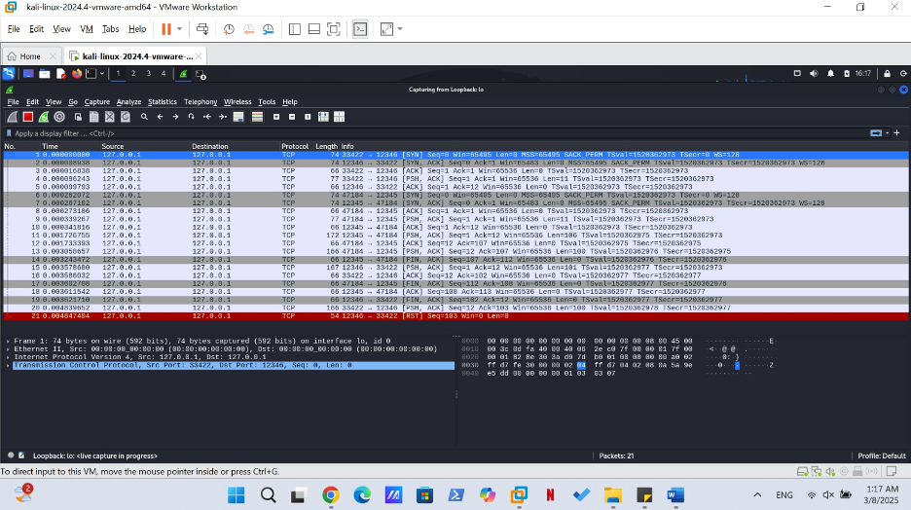

Figure 29. Wireshark Capture Overview

The captured network traffic in Wireshark reveals TCP communication that has been established between Alice, Bob and Trudy through ports 12345 and 12346 using SYN, SYN-ACK, and ACK packet exchanges. Some network exchanges stand out with highlights indicating that there is a suspicious actions have been created by the attacker such as interception and alterations of the communicated messages between Alice and Bob.

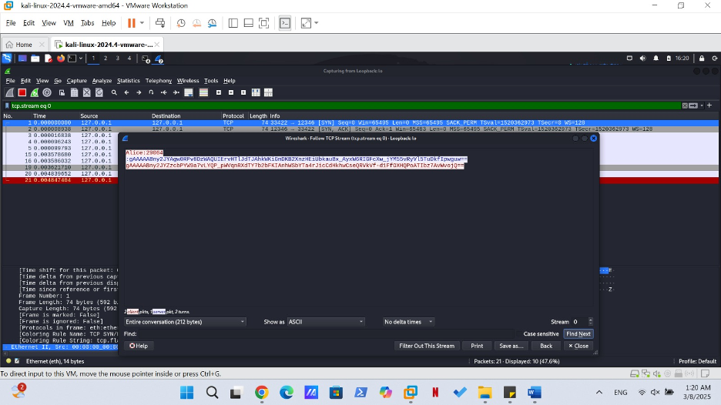

Figure 30. TCP Stream View

The TCP Stream view shows the communication sequence between Alice and Bob. The communication starts when Alice sends an authentication message which Bob responds with an encrypted message. The communication between Alice and Bob falls under Trudy's control who manages to succeed in the interception. The use of unencrypted authentication data demonstrates that there is a poor encryption quality because Trudy was able to obtain Alice credential information.

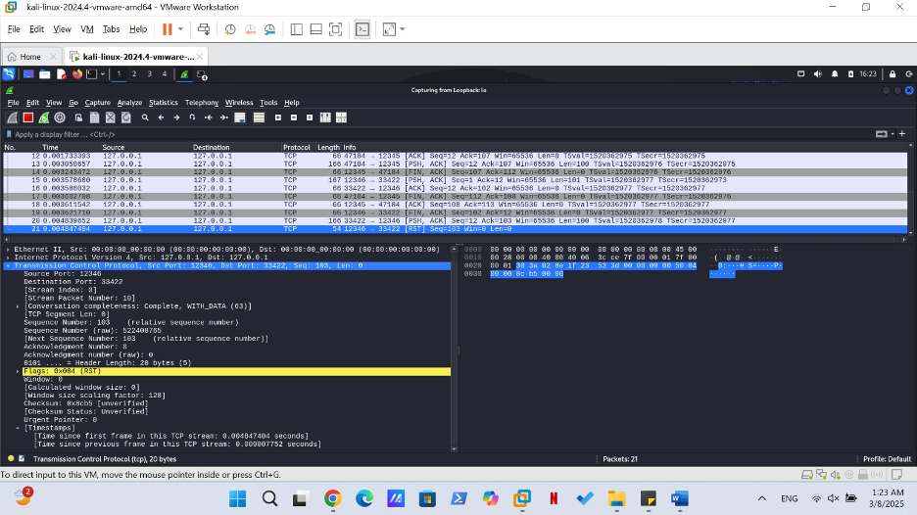

Figure 31. TCP RST Packets

A packet shows TCP RST (Reset) when it is forced to disconnect an active connection. There is different scenarios where such occurrences could happen:

* The security protocol caused Bob to stop the session because he noticed unexpected patterns.
* The attacker has been the cause of the disruption of a communication which could have been caused either by mistake or intentionally.
* A security system firewall could have prevented any unauthorized connection attempt.

When the traffic packet displayed multiple RST packets, this indicated that an attacker had an impact on the session's operation until it had terminated suddenly. The termination may serve as either a security defense measure that stops further harm or represents a secondary effect of the attack.

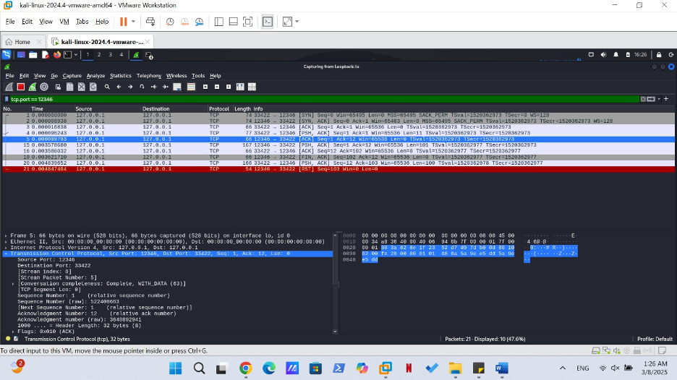

Figure 32. TCP Port 123456

The Wireshark analysis tracks the traffic exchanged on port 12346 between Alice and Bob of the interference of Trudy. The data logs confirm Trudy successfully took control of communications between Alice and Bob allowing potential modification of their messages. The packet payloads have shown that there is suspicious behavior that occurred due to attacker modifications of request parameters and inserted commands. Through packet injection the attacker made alterations and redirected messages that are the main characteristics of a MITM attack. This was an evidence that indicates that there was someone that have tampered with network communications because it points to the necessity of implementing encryption protection and integrity checks for network protocols.

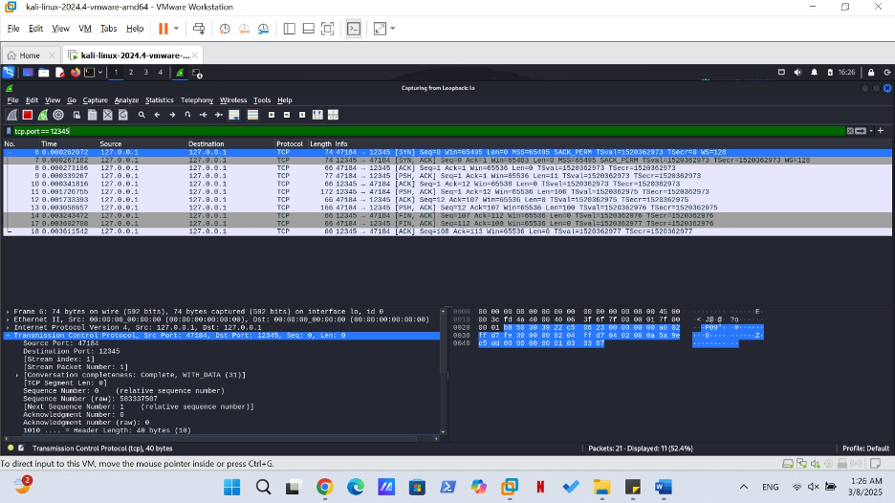

Figure 33. TCP Port 12345

The traffic of Bob sending his reply to Alice while Trudy intercepts it before sending it back to Alice. Trudy checks the received response before she finalizes its transmission as she will check if there are any modifications that needs to be done before sending it to Alice. This action indicates that:

* The attacker is under control over the data flow during the attack.
* When an attacker obtains Alice's credential information they can continue to manipulate her system through pretending to be her
* The attacker would have the ability to deliver misleading information or alteration of the original message, or even injection of malicious commands.

This attack is endangerment for both parties since none of them are aware that the authentication messages have been intercepted and undergone some alteration. As if the encryption has not been implemented using the advanced encryption techniques, the attacker would continue to attack without any knowledge of the other parties.

### TCPdump analysis

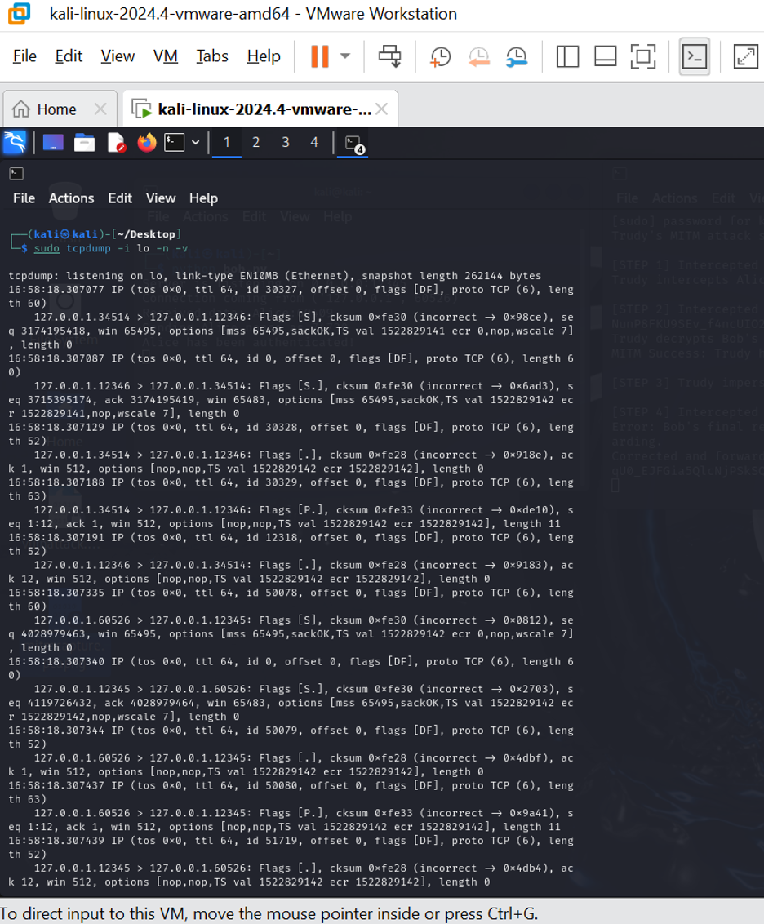

Figure 34. TCPdump Capture

The captured traffic implies that there is a Man-in-the-Middle (MITM) attack plus Replay Attack on the loopback interface (127.0.0.1). Due to the multiple TCP SYN packets, incorrect TCP checksum, and repeated connection attempts observed we can be sure that there is an attacker sniffing our packets and trying to replay them. Through these kind of attempts might include session hijacking, data manipulation, or process communication disruption. These suspicious detection were detected through these actions:

* Multiple SYN packets to various ports (34514, 12346, 12345, 60526).
* Incorrect TCP checksums, indicating the presence of either packet modification or replay.
* Identical TCP flags (SYN, ACK, PUSH, FIN) repeated.
* There's no expected response data, which suggests an interception or replayed traffic.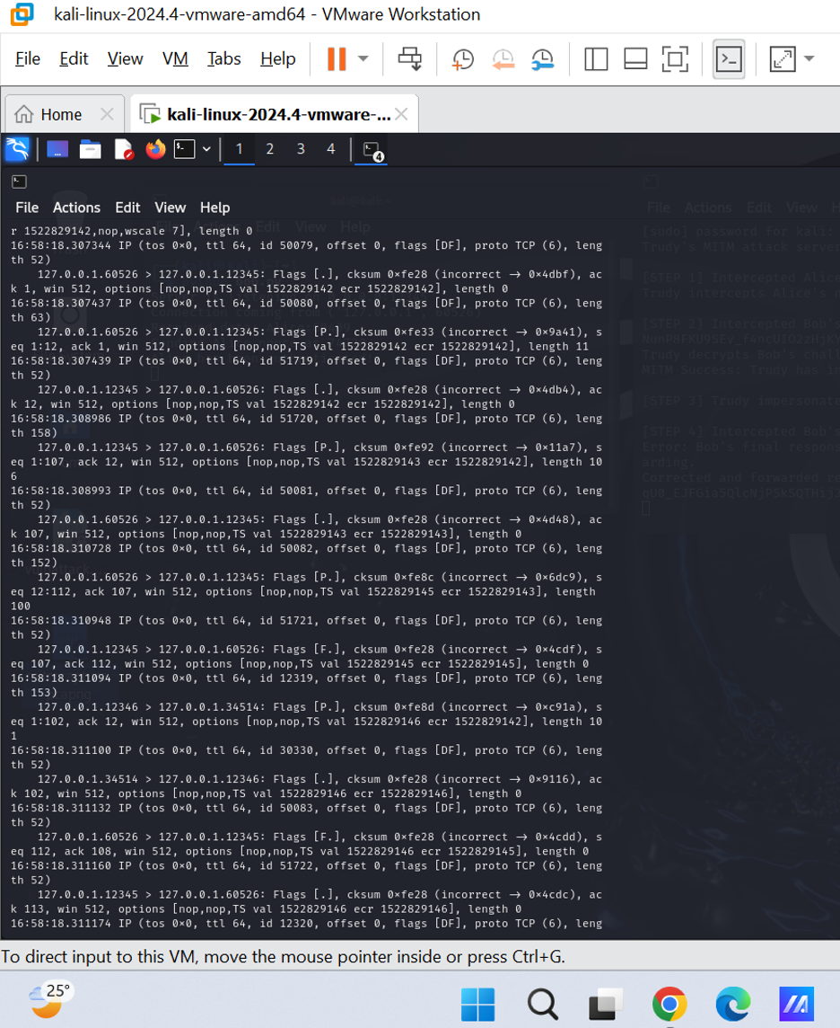

Figure 35. TCPdump Capture

The captured traffic also suggests that there is other possible packet injection and session manipulation other than MITM and replay attacks. The appearance of checksum errors along with the flags of FIN (F) and PUSH (P) means that the connections are being terminated suddenly or data packets are injected to modify network communication [3]. As well as, these findings of a loopback-based traffic indicates that there is an redirection that may occur through port patterns such as 12345, 60526, 34514 during the attack. These suspicious detection were detected through these actions:

* The appearance of checksums errors along FIN (F) indicates that there is a forced connection termination [3].
* The appearance of PUSH (P) flags in unusual sequences indicated that there was possible injected or replayed data [3].
* The mirrored traffic on multiple ports indicates that there has been a session redirection.
* The Offset and length inconsistency showcases that the packet is either fragmented or modified.

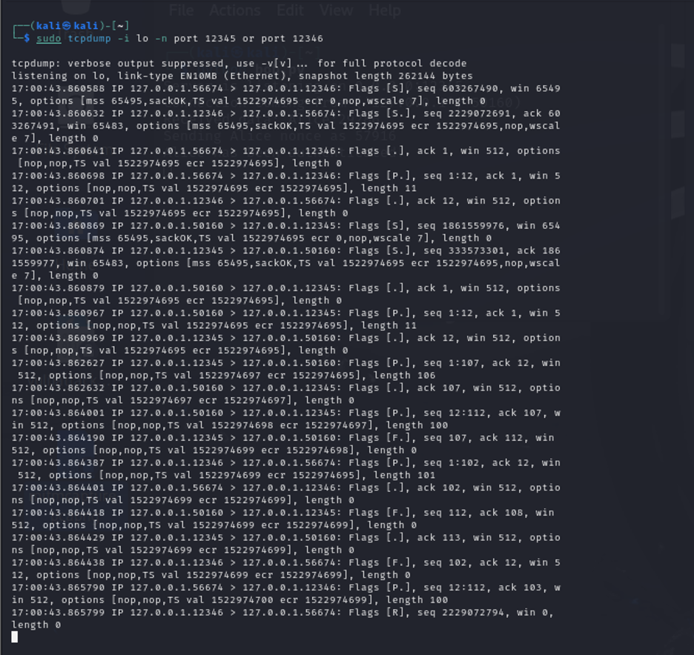

Figure 36. TCPdump on Port 12345 and 123456

As more sessions are being manipulated, the more possible data exfiltration and TCP stream hijacking. The presence of RST (R) and FIN (F) packets, especially when it comes in the wake of sequences of PUSH (P) and ACK (.) flags, showing that connections is forcibly reset in order to the kill active sessions [3]. The SYN (S) and then the ACK responses work on (within different ports; 12345, 12346, 56674, 50160, indicating an attacker of relay/replay traffic. Additionally, the observation of the PUSH (P) packets with a few payloads in them, which can cause a command injection through an open session [3]. The TCP checksums are also inconsistent that indicate that the packet modifications are not being able to be detected or the intended recipient isn't recognizing the modified packets as valid.

## Mitigation Security Analysis

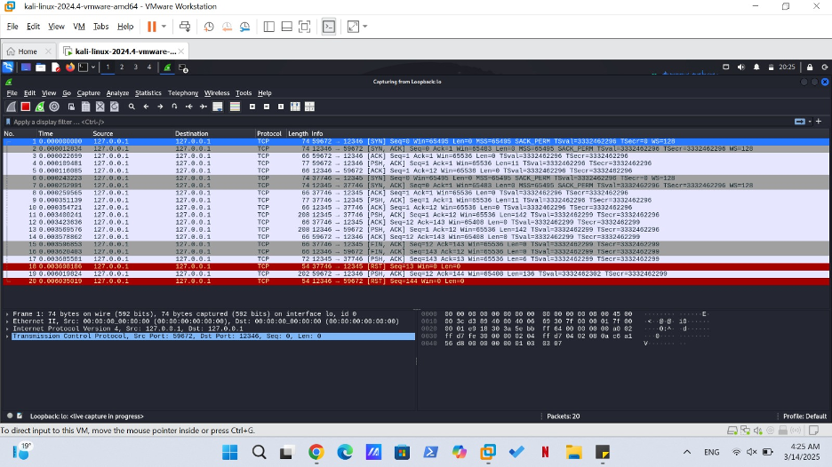

Figure: TCP RST Flag Mitigation

The captured data demonstrates the behavior of the TCP RST (Reset) flag within the network system. RPC connections terminate instantly when the TCP RST (Reset) flag is used or when networks try to establish unwanted connections. A device utilizes RST flag orders to instruct the other devices to both abort connection setups and terminate already formed connections.

**What Happens in the Capture**:

A packet includes the RST flag to communicate with either the client or server for performing a connection reset action. ETCH is employed to minimize dangerous or suspicious connections that try exploiting security holes or carry out TCP attacks like SYN flood attempts.

# 

Figure: TCP RST Flag and Connection Reset Mitigation

The figure demonstrates a TCP Reset (RST) flag usage which terminates a TCP connection abruptly. The RST flag functions within a connection reset procedure in this situation. Multiple key interactions can be found within the recorded packet data.

**TCP Handshake**:The TCP connection setup chronology starts with three packets that comprise SYN and SYN-ACK and ACK messages.

**TCP RST (Reset)**:The packet shows the RST flag set because one of the parties uses this protocol to reset the connection most likely because of an abnormal or malicious request.

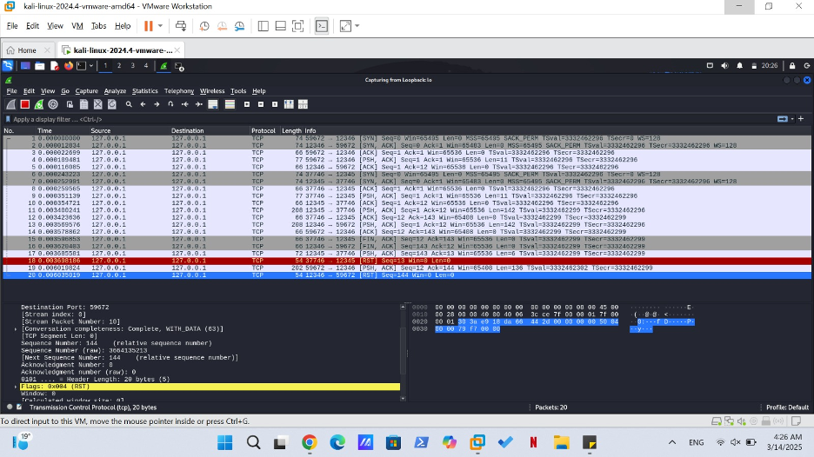

Figure: RST Flag for TCP Connection Reset

The figure above demonstrates usage of the TCP Reset (RST) flag throughout the packet examination. The RST flag of TCP protocol appears identically to other example figures because it functions to reset active TCP connections.

The monitored network communication follows standard TCP procedures starting from three handshake messages (SYN followed by SYN-ACK and finishing with ACK) between endpoints.

The packet stream shows a TCP RST flag during a later part of this sequence. The sending of a TCP reset flag alerts users about an ongoing connection disruption caused by one of the participating entities mainly the server or client.

A connection termination using the reset flag would stem from one of several different reasons.

Each endpoint has the power to terminate the connection independently before its scheduled time due to both errors and timeout durations and security breach recognition.

Numbers of systems employ an RST flag to terminate immediately all connections when detecting irregular activities or potential attack attempts such as SYN flood or connection hijacking.RST establishes safety through its ability to protect against hostile connections and fend off both Denial of Service (DoS) and other security risks that could target TCP-based systems by immediately terminating the connection.

# 

Figure: RST Flag with TCP Connection Reset

This packet reveals both TCP connection flow together with the RST (Reset) command that exists to immediately break active connections.

The TCP packets display how devices perform the handshake procedure and close their connection along the way. Both parties establish a connection through the standard SYN and SYN-ACK and ACK handshake session.

A packet holds the RST flag that shows termination of connection through forcible reset by one party towards the last part of the capture process.

# Conclusion

To sum up everything that has been stated so far, having a strong and advanced security on the authentication protocols needs to be within the implementation of the design when communicating between parties in order to prevent the risk of getting attack such as the replay and man-in-the-middle attacks. The first protocol implemented contained many vulnerabilities because it was a challenge-response communication. The addition of the nonce to the authentication has increased the security of the authentication message communication and that is because it had newer versions of encryption used through the communication messages. Through regular security checks on the network tools just as wireshark, ensure that if there is any possible vulnerability, it will be identified immediately to take actions in mitigating it. This process helps in creating the authentication system to be more secure and protected against any cyber threats.

# References

1. “wireshark(1).” <https://www.wireshark.org/docs/man-pages/wireshark.html#:~:text=Wireshark%20is%20a%20GUI%20network,a%20previously%20saved%20capture%20file>.
2. R. Gerardi, “An introduction to using tcpdump at the Linux command line,” *Opensource.com*. <https://opensource.com/article/18/10/introduction-tcpdump>
3. “Understanding TCP flags: Site24x7,” *Site24x7*. <https://www.site24x7.com/learn/linux/tcp-flags.html>
4. “Fernet (symmetric encryption) — Cryptography 45.0.0.dev1 documentation.” <https://cryptography.io/en/latest/fernet/>

# Appendix

**alice.py:**

**import socket**

**import random**

**from cryptography.fernet import Fernet**

**key = b'juFpmm064DZjCE_BVbergScbr-VRCAjbaeBXYX3deDM='**

**cipher = Fernet(key)**

**# Server configuration**

**HOST = '127.0.0.1' # localhost**

**PORT = 12345 # Port number**

**def authenticate(username, nonce):**

**client_socket = socket.socket(socket.AF_INET, socket.SOCK_STREAM)**

**client_socket.connect((HOST, PORT))**

**#FIRST MESSAGE FROM ALICE TO BOB**

**# Send and prints credentials in plaintext, this makes it vulnerable**

**challenge = f"{username}:{nonce}"**

**print("Sending Bob","'",username,':',nonce,"'")**

**client_socket.send(challenge.encode())**

**#ALICE RECEIVING MESSAGE FROM BOB AND DECRYPTING**

**# Receive response**

**response = client_socket.recv(1024).decode()**

**try:**

**username, res = response.split(":")**

**decode_message = cipher.decrypt(res.encode())**

**decrypted_message = decode_message.decode()**

**print('Received from Bob',username,':',decrypted_message)**

**if int(decrypted_message) == nonce:**

**print ("Bob has been authenticated!")**

**except Exception as e:**

**print(f"Error decrypting message: {e}")**

**# Split received data ("username:nonce")**

**enc = username.encode() #encoding message before encryption**

**enc_res = cipher.encrypt(enc) #encryption before sending to Bob**

**# Send response to client**

**response = f"{enc_res.decode()}"**

**client_socket.send(response.encode())**

**client_socket.close()**

**if __name__ == "__main__":**

**username = "Alice"**

**nonce = random.randint(10000,99999)**

**authenticate(username, nonce)**

**bob.py:**

**import socket**

**import random**

**from cryptography.fernet import Fernet**

**key = b'juFpmm064DZjCE_BVbergScbr-VRCAjbaeBXYX3deDM='**

**cipher = Fernet(key)**

**# Server configuration**

**HOST = '0.0.0.0' # Listen to all network**

**PORT = 12345 # Port**

**# Credentials for successful authentication (Username, Password)**

**user_credentials = {"alice": "password123", "bob": "securepass"}**

**def handle_client(client_socket):**

**try:**

**#BOB RECEIVING MESSAGE, ADDING HIS NONCE AND ENCRYPTING ALICE MESSAGE**

**# Receive authentication data**

**data = client_socket.recv(1024).decode()**

**print("Received data:",data)**

**# Split received data ("username:nonce")**

**username, a_nonce = data.split(":")**

**encode_challenge = a_nonce.encode()**

**encrypted_challenge = cipher.encrypt(encode_challenge)**

**username = random.randint(10000,99999)**

**print("Sending Alice nonce as",username)**

**# Send response to client**

**response = f"{username}:{encrypted_challenge.decode()}"**

**client_socket.send(response.encode())**

**#BOB RECEIVING FINAL MESSAGE FROM ALIC**

**# Receive authentication data**

**data = client_socket.recv(1024).decode()**

**try:**

**#print(username)**

**#print(f"Encrypted message: {res}")**

**dec_mes = cipher.decrypt(data.encode())**

**d_m = dec_mes.decode()**

**if int(d_m) == username:**

**print ("Alice has been authenticated!")**

**except Exception as e:**

**print(f"Error decrypting message: {e}")**

**except Exception as e:**

**print(f"Socket Error: {e}")**

**finally:**

**client_socket.close()**

**def start_server():**

**server_socket = socket.socket(socket.AF_INET, socket.SOCK_STREAM)**

**server_socket.bind((HOST, PORT))**

**server_socket.listen(5)**

**print(f"Server is listening on {HOST}:{PORT}")**

**while True:**

**client_socket, addr = server_socket.accept()**

**print(f"Connection coming from {addr}")**

**handle_client(client_socket)**

**if __name__ == "__main__":**

**start_server()**

**alicem.py:**

**import socket**

**import os**

**import base64**

**from cryptography.fernet import Fernet**

**key = b'juFpmm064DZjCE_BVbergScbr-VRCAjbaeBXYX3deDM=' # Shared key**

**cipher = Fernet(key)**

**SERVER_IP = "127.0.0.1"**

**SERVER_PORT = 12346**

**def authenticate():**

**with socket.socket(socket.AF_INET, socket.SOCK_STREAM) as client_socket:**

**client_socket.connect((SERVER_IP, SERVER_PORT))**

**# Step 1: Alice sends her identity and a random nonce (R_A)**

**alice_nonce = str(10000 + int.from_bytes(os.urandom(2), 'big'))**

**message = f"Alice:{alice_nonce}"**

**print(f"Sending: {message}")**

**client_socket.send(message.encode())**

**# Step 2: Receive Bob's nonce and encrypted challenge**

**response = client_socket.recv(1024).decode()**

**bob_nonce, encrypted_challenge = response.split(":")**

**# Decrypt challenge from Bob**

**try:**

**decrypted_challenge = cipher.decrypt(base64.b64decode(encrypted_challenge)).decode()**

**print(f"Received and decrypted challenge: {decrypted_challenge}")**

**except:**

**print("Decryption failed. Possible MITM attack!")**

**client_socket.close()**

**return**

**# Verify Bob’s identity**

**if decrypted_challenge.startswith("Bob") and alice_nonce in decrypted_challenge:**

**print("Bob successfully verified!")**

**# Step 3: Encrypt Bob's nonce and send final authentication**

**final_auth = base64.b64encode(cipher.encrypt(f"Alice:{bob_nonce}".encode())).decode()**

**client_socket.send(final_auth.encode())**

**# Step 4: Receive Bob’s verification**

**verification = client_socket.recv(1024).decode()**

**if verification == "Authenticated":**

**print("Successfully authenticated with Bob!")**

**else:**

**print("Authentication failed.")**

**else:**

**print("Bob's verification failed. Possible attack detected.")**

**if __name__ == "__main__":**

**authenticate()**

**bobm.py:**

**import socket**

**import os**

**import base64**

**from cryptography.fernet import Fernet**

**key = b'juFpmm064DZjCE_BVbergScbr-VRCAjbaeBXYX3deDM=' # Shared key**

**cipher = Fernet(key)**

**HOST = '0.0.0.0'**

**PORT = 12345**

**def handle_client(client_socket):**

**try:**

**# Step 1: Receive Alice’s initial message**

**data = client_socket.recv(1024).decode()**

**username, alice_nonce = data.split(":")**

**print(f"Alice sent nonce: {alice_nonce}")**

**# Step 2: Generate Bob's nonce (R_B) and encrypt challenge**

**bob_nonce = str(10000 + int.from_bytes(os.urandom(2), 'big'))**

**challenge = f"Bob:{alice_nonce}"**

**encrypted_challenge = base64.b64encode(cipher.encrypt(challenge.encode())).decode()**

**response = f"{bob_nonce}:{encrypted_challenge}"**

**client_socket.send(response.encode())**

**# Step 3: Receive and verify final authentication from Alice**

**final_auth = client_socket.recv(1024).decode()**

**try:**

**decrypted_auth = cipher.decrypt(base64.b64decode(final_auth)).decode()**

**except:**

**print("Decryption failed. Possible MITM attack!")**

**client_socket.send("Failed".encode())**

**return**

**if decrypted_auth == f"Alice:{bob_nonce}":**

**print("Alice authenticated successfully!")**

**client_socket.send("Authenticated".encode())**

**else:**

**print("Authentication failed.")**

**client_socket.send("Failed".encode())**

**except Exception as e:**

**print(f"[-] Error: {e}")**

**finally:**

**client_socket.close()**

**def start_server():**

**server_socket = socket.socket(socket.AF_INET, socket.SOCK_STREAM)**

**server_socket.bind((HOST, PORT))**

**server_socket.listen(5)**

**print(f"Server is listening on {HOST}:{PORT}")**

**while True:**

**client_socket, addr = server_socket.accept()**

**print(f"Connection from {addr}")**

**handle_client(client_socket)**

**if __name__ == "__main__":**

**start_server()**

## 